Chapter 14, Solution 81.

(a)
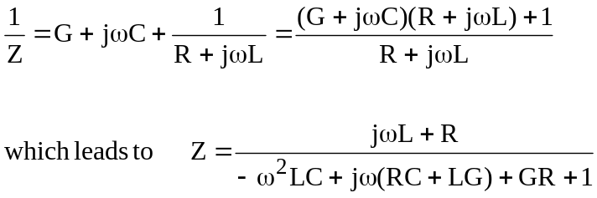

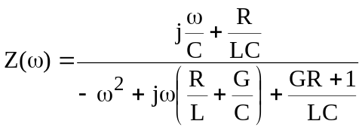 (1)

We compare this with the given impedance:

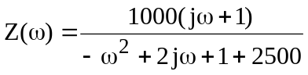 (2)

Comparing (1) and (2) shows that

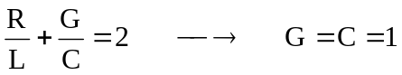 mS

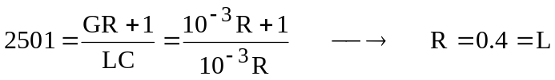
Thus,

R = 0.4Ω, L = 0.4 H, C = 1 mF, G = 1 mS

- By frequency-scaling, K_{f} =1000.

R’ = 0.4 Ω, G’ = 1 mS

 